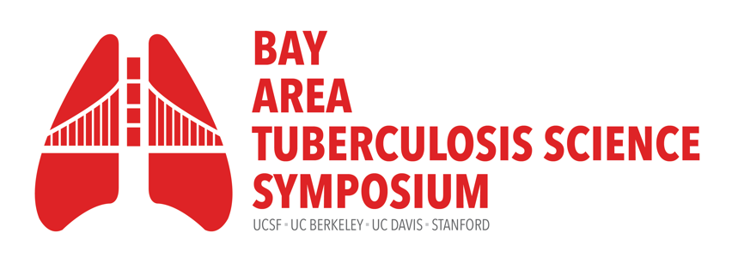
Friday, September 9, 2022
8:30am – 5:00pm

Fisher Banquet Room, Mission Bay. University of California, San Francisco
Hosted by the UCSF Center for Tuberculosis

Time | Presenter(s) | Title
8:00am | Registration check-in, poster set-up  Continental breakfast & coffee/tea service
8:30am | Babak Javid, MB BChir, PhD  Professor, Medicine, UCSF  Sarah Stanley, PhD  Associate Professor, UC Berkeley | Welcome Remarks
8:50am | Payam Nahid, MD, MPH  Director, UCSF Center for Tuberculosis | Keynote Introduction
8:55am | Richard E. Chaisson, MD  Johns Hopkins University | Keynote talk: TB Elimination: Tilting at Windmills?
11:00am | Bennett Penn, MD, PhD, UC Davis | Networking Session
10:40am | Coffee Break
11:00am | Session moderator:  Gustavo Velásquez, MD, MPH  UCSF | Oral Abstracts
- Andrea Fossati, UCSF
- Dmitri Kotov, UC Berkeley
- Haig Eskandarian, UCSF
- Jillian Kadota, UCSF
12:00pm | Session moderator:  Shoshana Zha, PhD, Assistant Professor, UCSF | Invited Talks
- BATS Rising Star Award: Devan Jaganath, UCSF
- Taia Wang, Stanford University
- Steven Conolly, UC Berkeley
- Rada Savic, UCSF
1:15pm | Lunch and Poster Session
3:00pm | Session moderator:  Adithya Cattamanchi, MD, MAS  UCSF | Invited talks
Invited Talks
- Suzanne Dufault, UCSF
- Imran Khan, UC Davis
- Jon Budzik, UCSF
- Sarah Stanley, UC Berkeley
4:00pm | Sarah Stanley, PhD, UC Berkeley | Poster Awards
4:10pm | Babak Javid, MB BChir, PhD, UCSF | Closing Remarks
4:15-5:00pm | Wine and cheese reception

On behalf of the UCSF Center for Tuberculosis and the Bay Area TB Symposium Committee,
Thank You to Our Sponsors

