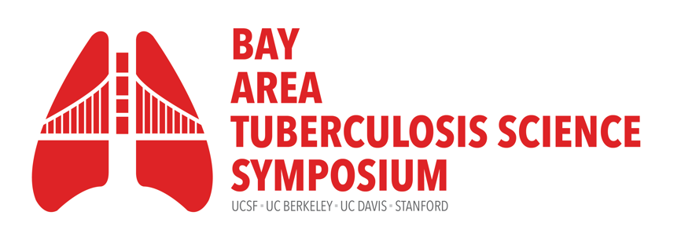
Thursday, September 26, 2024
9:00am – 6:00pm

Fisher Banquet Room, Mission Bay. University of California, San Francisco
Hosted by the UCSF Center for Tuberculosis

Time | Presenter(s) | Title
8:00-9:00am | Registration check-in, poster set-up  Continental breakfast & coffee/tea service
9:00-9:25am | Babak Javid, MB BChir, PhD  Professor, Medicine, UCSF  Sarah Stanley, PhD  Associate Professor, UC Berkeley | Welcome Remarks
9:25-9:30am | Payam Nahid, MD, MPH  Executive Director, Institute for Global Health Sciences, UCSF | Keynote Introduction
9:30-10:15am | Dr. Megan Murray, MD, ScD  Adjunct Professor of Immunology and Infectious Diseases, Harvard University | Keynote talk:  Genomic Epidemiology of TB in Peru
10:15-10:55am | Session moderator:  Sara Suliman, PhD, MPH  Assistant Professor, UCSF | Invited talks
 | Russell Vance, PhD  Professor, Department of Molecular & Cell Biology  UC Berkeley, and HHMI Investigator | The innate immune response during tuberculosis
 | Brenna Henn, PhD  Associate Professor, Department of Anthropology, UC Davis | Illuminating genome-wide host genetic architecture of TB susceptibility
10:55-11:25am | Coffee Break: 30min
11:25am-12:10pm | Session moderator:  Bennett Penn, MD, PhD  Assistant Professor, UC Davis | Oral Abstracts
 | Caitlin Moe, MS, PhD  Academic Specialist, UC Irvine/UCSF | A vibroacoustic signature to classify tuberculosis severity: development and multi-country evaluation
 | Paul Ogongo, PhD  Assistant Researcher, Medicine, UCSF | Increased circulating Th17 cells and differential skewing of CD4 T cell maturation and proliferation in tuberculosis patients with type 2 diabetes
 | Nicholas Bates, BS  Graduate Student, UC Davis | The catalase-peroxidase KatG is a regulator of multidrug antibiotic tolerance in Mycobacterium abscessus
12:10-1:40pm | Lunch and Poster Session
1:40-2:40pm | Sarah Hutch, Associate Director  UCSF Center for Tuberculosis | Networking Session
2:40-3:10pm | Coffee Break: 30min
3:10-4:30 PM | Session moderator:  Babak Javid, MB BChir, PhD, UCSF  Professor, Medicine, UCSF | Invited talks
 | Antonio Pagán, PhD  Assistant Professor, Department of Microbiology and Immunology, Stanford University | Winner, 2024 BATS Rising Star Award  (award presented by Babak Javid)  ‘Non-canonical’ roles of autophagy-related proteins in anti-mycobacterial immunity
 | Amy Tang, MD  Director of Immigrant Health  North East Medical Services, San Francisco | Can Primary Care Drive TB Elimination? A Community Health Center’s Experience with Scaling Up TB Prevention and Care Services for Non-US Born Populations
 | Jonathan Izudi, MPH, MSc, PhD  Honorary Research Fellow,  Department of Community Health, Faculty of Medicine, Mbarara University of Science and Technology, Uganda.  UC TRAC Global Fellow | Negative effects of undernutrition on sputum smear conversion and treatment success among retreatment cases in Uganda: a quasi-experimental study
 | Andrew Kerkhoff, MD, PhD, MS  Assistant Professor, Medicine, UCSF | Needs and Wants: Integrating Preferences to Advance People-Centered TB Research and Services
4:30-4:35pm | Devan Jaganath, MD, MPH  Assistant Professor, UCSF | Poster Awards
4:35-4:40pm | Sarah Stanley, PhD  Associate Professor, Immunology and Molecular Medicine, UC Berkeley | Closing Remarks
4:40-6:00pm | Wine and cheese reception

On behalf of the UCSF Center for Tuberculosis and the Bay Area TB Symposium Committee,
Thank You to Our Sponsors
