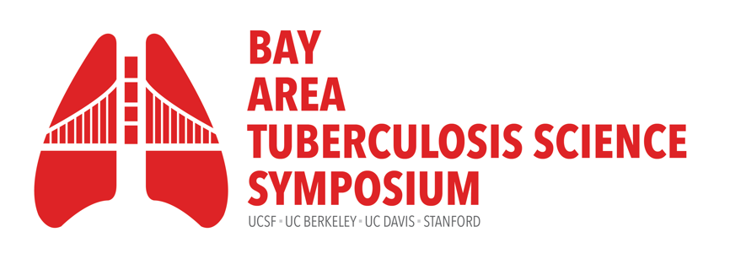
Thursday, September 25, 2025
9:00am – 4:30pm

Fisher Banquet Room, Mission Bay. University of California, San Francisco
Hosted by the UCSF Center for Tuberculosis

Time | Presenter(s) | Title
8:00-9:00am | Registration check-in, poster set-up  Continental breakfast & coffee/tea service
9:00-9:25am | Payam Nahid, MD, MPH  Executive Director, Institute for Global Health Sciences, UCSF  Sarah Stanley, PhD  Associate Professor, UC Berkeley | Welcome Remarks
9:25-9:30am | Payam Nahid, MD, MPH  Executive Director, Institute for Global Health Sciences, UCSF | Keynote Introduction
9:30-10:15am | Mark Davis, PhD  The Burt and Marion Avery Family Professor of Immunology, Stanford University School of Medicine | Keynote talk:  Quantiferon negative individuals in the Cape Town Adolescent Cohort have been infected with Mtb, but make a very different T cell response
10:15-11:15am | Session moderator:  Babak Javid, MB BChir, PhD  Associate Professor, UCSF | Invited talks
 | Rada Savić, PhD  Professor, Department of Bioengineering and Therapeutic Sciences, UCSF | Re-imagining TB regimen design
 | Joel Ernst, MD  Professor, Medicine  Chief, Experimental Medicine, UCSF | Challenges to T cell immunity in TB
 | Grant Theron, BSc, BSc (Honors), MSc, PhD  Professor, Molecular Biology and Human Genetics, Stellenbosch University, South Africa | Diagnostic accuracy of near point-of-care tests for predicting incident TB: Findings from the multicountry PreFIT study.
11:15-11:45am | Coffee Break: 30min
11:45am-12:30pm | Session moderator:  Bennett Penn, MD, PhD  Assistant Professor, UC Davis | Oral Abstracts
 | Esther Jung, MPH  Stanford University | Intensive screening reduces tuberculosis transmission over time in prisons
 | Zaynab Mousavian  Emory University (UCSF visiting scholar) | Machine learning of plasma multi-omics data distinguishes pulmonary tuberculosis from other respiratory infections
 | Alex Zilinskas  UC Berkeley | Mycobacterium tuberculosis alters the T helper response via the type VII secretion system ESX-1 and lipid virulence factor phthiocerol dimycocerosate
12:30-2:00pm | Lunch and Poster Session
2:00-3:00pm | Session moderator:  Antonio Pagán, PhD  Assistant Professor, Stanford University | Invited talks
 | Andrew Kerkhoff, MD, PhD, MS  Assistant Professor, Medicine, UCSF | Winner, 2025 BATS Rising Star Award  “Prevention is better than cure” - A Mixed Methods Study of Communities’ and Healthcare Workers’ Perspectives on New Adult and Adolescent TB Vaccines and their Implementation in Zambia
 | Lelia Chaisson, PhD, MSc  Assistant Researcher, GHS Programs, UCSF | Clinical and epidemiologic sex differences in TB and TB/HIV
 | Jeff Cox, PhD  Professor, C.H. Li Chair of Biochemistry and Molecular Endocrinology  Faculty Director, Center for Emerging and Neglected Diseases  UC Berkeley | Modeling TB Meningitis
3:00-3:15pm | Coffee Break
3:15-4:15pm | Session moderator:  Bennett Penn, MD, PhD  Assistant Professor, UC Davis  Sarah Stanley, PhD  Associate Professor, Immunology and Molecular Medicine, UC Berkeley  Adithya Cattamanchi, MD, MAS  Professor of Medicine and Public Health  Chief, Division of Pulmonary Diseases and Critical Care Medicine, UC Irvine  Gustavo Velásquez, MD, MPH  Assistant Professor, Medicine, UCSF | Panel discussion on TB research
4:15-4:20pm | Philip Hopewell, MD  Professor, School of Medicine, UCSF | Poster Awards
4:20-4:30pm | Babak Javid, MB BChir, PhD  Associate Professor, UCSF | Closing Remarks

On behalf of the UCSF Center for Tuberculosis and the Bay Area TB Symposium Committee,
Thank You to Our Sponsors




