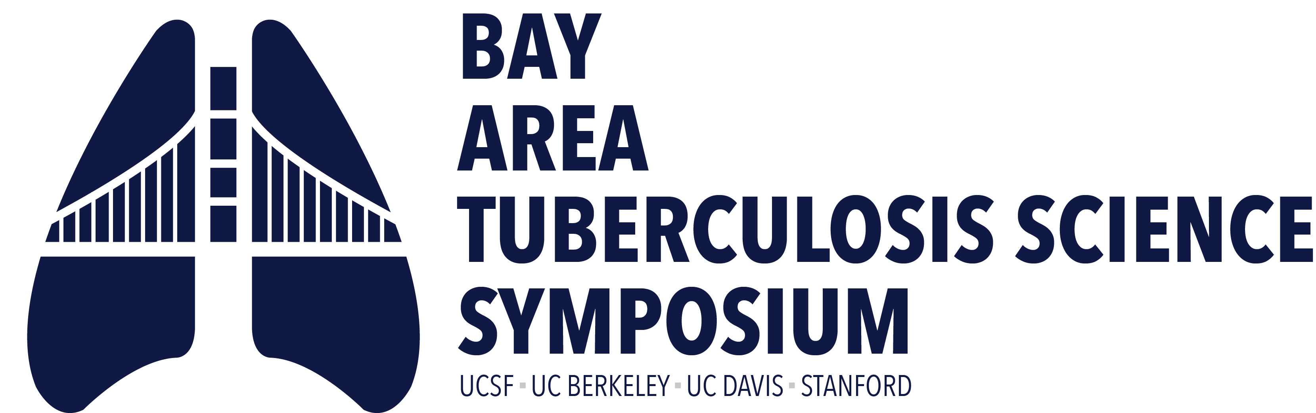
Thursday, October 8, 2026
9:00am – 6:00pm

Fisher Banquet Room, Mission Bay. University of California, San Francisco
Hosted by the UCSF Center for Tuberculosis

Time | Presenter(s) | Title
8:00-9:00am | Registration check-in, poster set-up  Continental breakfast & coffee/tea service
9:00-9:25am | Payam Nahid, MD, MPH  University of California, San Francisco  Executive Director, Institute for Global Health Sciences  Bennett Penn, MD, MPH  University of California, Davis  Assistant Professor, School of Medicine | Welcome Remarks
9:25-9:30am | Payam Nahid, MD, MPH  University of California, San Francisco  Executive Director, Institute for Global Health Sciences | Keynote Introduction
9:30-10:15am | Susan Dorman, MD  Medical University of South Carolina  Professor of Medicine & Faculty Director  Center for Global Health | Keynote talk: Breathless: The Global War Against Tuberculosis
10:15-11:15am | Session moderator:  Jonathan Budzik, MD, PhD  University of California, San Francisco  Assistant Professor, School of Medicine | Invited talks
 | Leonardo Martinez, PhD, MPH  University of California, Berkeley  School of Public Health  Division of Epidemiology | Measles, Immune Disruption, and Tuberculosis Risk: Population-Based Evidence From China
 | Carina Marquez, MD, MPH  University of California, San Francisco  Professor, Division of HIV, Infectious Diseases, and Global Medicine  School of Medicine | Social-Spatial Networks and Tuberculosis Infection in Children and Adolescents
 | Babak Javid, MB BChir, PhD  University of California, San Francisco  Associate Professor, Division of Experimental Medicine | Protective Mtb-specific antibodies exert a vaccinal effect in experimental TB infection
11:15-11:45am | Coffee Break: 30min
11:45am-12:30pm | Session moderator:  Fatoumatta Darboe, PhD  University of California, San Francisco  Professional Researcher, Division of Experimental Medicine | Oral Abstracts
 | Ifeanyichukwu Eke  Stanford University  Postdoctoral Scholar, Department of Pathology, | Alkyl-aryl phosphonates as covalent inhibitors of mycobacterial serine protease Hip1
 | Isabel Lamb-Echegaray  University of California, Berkeley  PhD Candidate, Public Health Department | Elucidating the mechanisms and correlates of protection elicited by CDN adjuvanted vaccines for M. tuberculosis
 | Christopher Rae  University of California, Berkeley  Postdoctoral Researcher, Division of Biochemistry, Biophysics and Structural Biology | Preliminary discovery of novel inhibitors of Mycobacterium tuberculosis from rare Actinomycetota soil bacteria
12:30-1:00pm | Lunch
1:00-2:00pm | Poster session
2:00-3:00pm | Session moderator:  Antonio J. Pagán, PhD,  Stanford University  Assistant Professor, Department of Microbiology and Immunology | Invited talks
 | Sophie Huddart, PhD  University of California, San Francisco  Assistant Professor, Department of Epidemiology and Biostatistics and IGHS  Award presented by Adithya Cattamanchi and Devan Jaganath | Winner, 2026 BATS Rising Star Award  When the average is not average: Exploring trajectory-based analyses
 | Janice Louie, MD, MPH  San Francisco Department of Public Health  Medical Director, Tuberculosis Prevention and Control Program | An Upside-Down Epidemic: Barriers to TB Care in a Resource-Rich Setting
 | James Chen, PhD  University of California, San Francisco  Assistant Professor, Department of Microbiology and Immunology | Rv2571c: A Novel Determinant of Pyrazinamide Susceptibility in Mycobacterium tuberculosis
3:00-3:15pm | Coffee Break
3:15-4:15pm | Session moderator: TBD | 5th Anniversary session
4:15-4:20pm | Philip Hopewell, MD  University of California, San Francisco  Professor, School of Medicine | Poster Awards
4:20-4:30pm | Sarah Stanley, PhD  University of California, Berkeley  Associate Professor, Molecular and Cell Biology | Closing Remarks
4:30-6:00pm | Wine & Cheese Reception

